Profesor/a: Angie Steffany Pineda 7A – 7B Miguel Ángel Sanabria 7C
Asignatura: Inglés |  | Grados: 7A 7B y 7C
Nombre del estudiante: https://us04web.zoom.us/j/9457404855?pwd=Y0UyQkJKNlgrZ3Azc2kxZ2Jra2FrUT09
Contacto del docente y horarios: | angiespineda@gmail.com HORARIO:  Celular 3204142339  migue09647@hotmail.com miguelangelsanabriaensas@gmail.com  Celular 3115065316 HORARIO: Miércoles 2:00 a 4:00 pm
Segundo periodo | TEMA: Democracy and Peace. Bullying and conflicts
Que conocimiento va a adquirir el estudiante
Competencia de aprendizaje | El estudiante estará en la capacidad de identificar vocabulario y expresiones referidas a feelings and emotions y a partir de los conceptos aprendidos describirá una imagen en las que aplicará referentes temáticos como presente y pasado continuo.
¿QUE VOY A APRENDER?
Dear seventh grade student. Through this first guide for this second term you will learn about feelings and emotions by means of videos and reading comprehension activities. You will explore and learn vocabulary and expressions related to things you do and how they affect you. We will go through listening, reading and writing activities. After having a more detailed knowledge about these concepts you will be able to express your ideas by describing a photo in which you talk about your feelings and emotions.

Warm-up

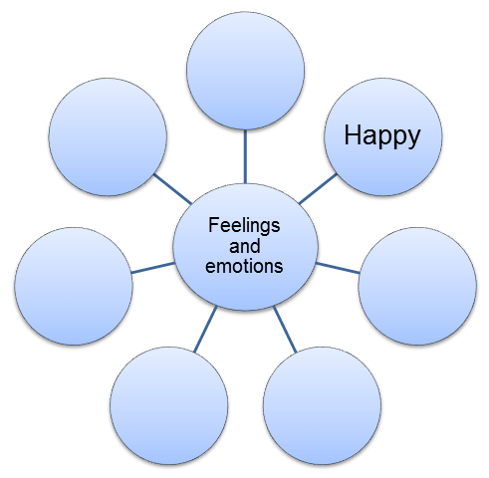
Have a look at the following bubble map graphic organizer (you can draw in in your notebook) and;
Write some more words related to the topic (at least 10) “feelings and emotions”. What other words can you think of? Look at the example given “happy”. Do not use a dictionary or internet. Write ONLY words you know.
- _______________ 6. _______________
- _______________ 7. _______________
- _______________ 8. _______________
- _______________ 9. _______________
- _______________ 10._______________

LO QUE ESTOY APRENDIENDO (CONCEPTOS – ESTRUCTURA DEL TEMAS)

Video Time. Vocabulary and Pronunciation

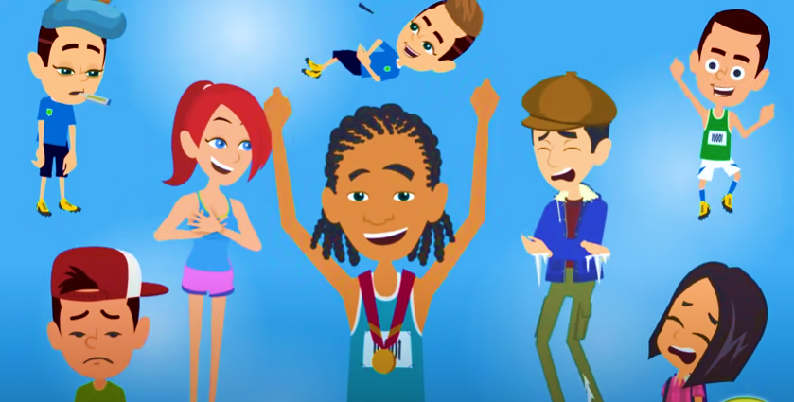
So far we have explored vocabulary words you know about feelings and emotions. Now, we are going to watch a short video entitled “Feelings and emotions Vocabulary” so you can expand your knowledge about the topic. https://www.youtube.com/watch?v=7uY2HrQ9qQ8

Make a list with the words that are new for you. Use the Word Bank chart below.

Word bank!!
Words that are new for me.
Vocabulary in context.
At this time we have been learning some vocabulary words related to feelings and emotions. In this exercise we are going to put those new words in context.
Look at the picture and match the words in the box to the feelings / emotions people in the pictures are experiencing.
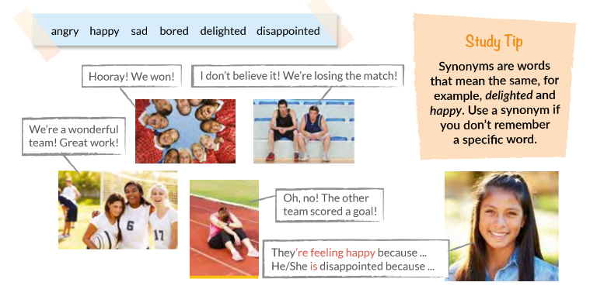
What about you?
Think about your feelings and emotions and answer these questions. Look at the example:
Example:
Walking my dog makes me happy
What makes you happy?

What makes you __________ (feeling)? ___________ing makes me __________.
- What makes you sad? _________________________________.
- What makes you angry? _________________________________.
- What makes you excited? _________________________________.
- What makes you cry? _________________________________.
- What makes you scared? _________________________________.

PRACTICO LO QUE APRENDÍ
Practice
Now, we are going to read about César, a Colombian student, the things he does and how he feels about them. Read the short text ad complete the chart below.

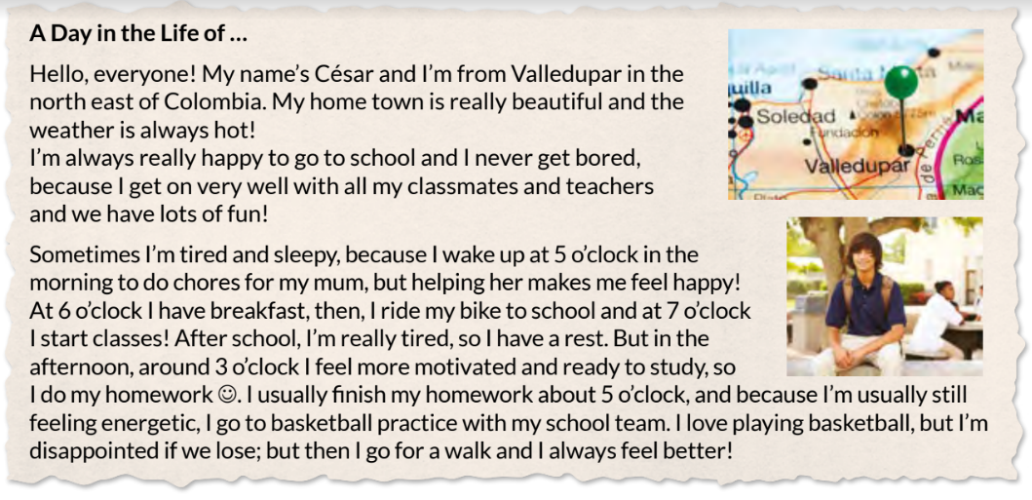

When | How he feels | What he does
5 a.m.
After school
3 p.m.
After 5 p.m
Lose a match

Writing
Finally, you are going to write about your feelings and emotions. Choose a family picture in which you are included OR any picture you like and think about the people in the picture and their feelings and emotions at that specific moment. Make emphasis on your emotions and the reasons you had to feel in that specific manner.


Think of these questions.

Who are people in the picture?
Where are they?
Where was it taken?
What were they doing / celebrating?
Was it a special time for you and your family? Why?

THIS ACTIVITY WILL BE FURTHERLY EXPLAINED DURING VIRTUAL SESSIONS!

¿CÓMO SÉ QUE APRENDÍ?

Respetado estudiante, en el propósito de identificar aciertos y aspectos por mejorar tanto en el contenido del taller como en las actividades propuestas, favor responder las siguientes preguntas;

¿Sé logró la meta de aprendizaje?
¿Qué dificultades encontraste?
¿Que podría mejorar?

AUTOEVALUACIÓN
Apreciado estudiante, valora sincera y honestamente los indicadores de desempeño que a continuación se detallan de acuerdo a nuestra escala de valoración de 10 a 100
INDICADORES DE DESEMPEÑO | VALORACION
Para el ser (Actitudinal) | Nota de 10 a 100
Se distingue por vivenciar una excelente formación integral, manteniendo asertivas relaciones de convivencia fraterna con las personas y su entorno.
Para el saber (Conceptual) | Nota de 10 a 100
Identifica palabras y expresiones relacionadas con el manejo de emociones, valores, cualidades, sugerencias y recomendaciones.
Para el saber hacer (Procedimental)  Produce textos descriptivos cortos y sencillos en los que intercambia ideas relacionadas con sugerencias y recomendaciones, emociones, valores y cualidades. | Nota de 10 a 100

